World Regional Geography Activity 2: Names: Luke Pepin

**Connections in Turkiye’s Geography?**

In this activity, we will examine a number of maps of the country Turkiye. Please answer the associated questions about connectedness in that country. Fill out this sheet and post your answers as a **Word Document or PDF** to the location where you found this file on HuskyCT.

1. Think of the Site and Situation of Turkiye in the context of global networks. What gives it advantages or disadvantages?

One of the biggest advantages that Turkiye has in the context of global network is full control over passage between the Aegan (and by greater extent the Levantine and Mediterranean) Sea and the Black Sea. Giving it a large amount of control over trade from the countries on the Black Sea.

However, one disadvantage that Turkiye faces is that it borders a politically contentious region of the world in the Middle East. While full of culture such a charged region can be difficult to navigate diplomatically, and Turkey may often finds itself dealing with complex geopolitical challenges

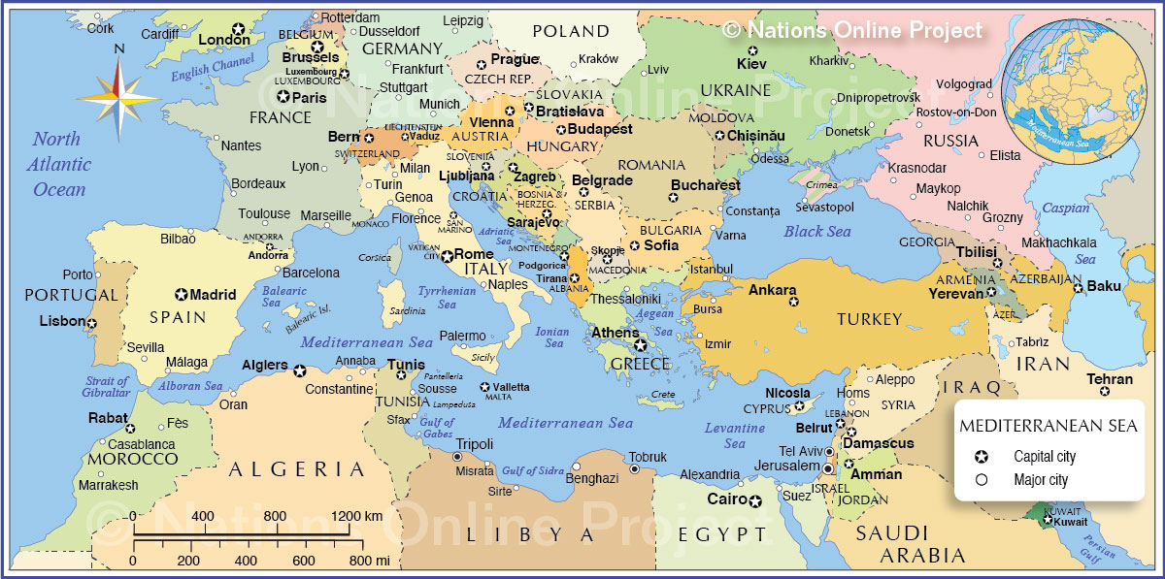

1. Consider the ethnic mix of Turkiye and the broader picture of Southwest Asia. How does this influence our thinking of other aspects of development in Turkey?

While the primary ethic group of Turkiye are the Turks, it is comprised of various groups and ideologies that make it a very diverse country. This breaks down the common thinking of a homogenous country that Turkiye is a country of different regions and people with different views and lives.

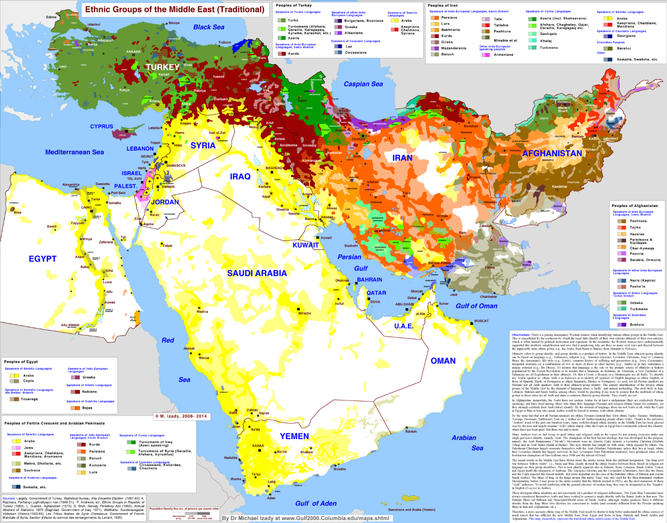

1. Now consider the major road network in Turkiye and major railways. Does the transportation network in Turkey reflect a hub and spoke system? How?

A hub-and-spoke system is a transport system in which passengers travel from smaller hubs to larger hubs to make longer trips. This is true for Turkiye, given the Turkiye system does not focus on motorways but railways the system reflect the hub-and-spoke system as passengers would enter the transport system most often through a smaller train station and for longer trips would enter a much larger hub which connects multiple rails.

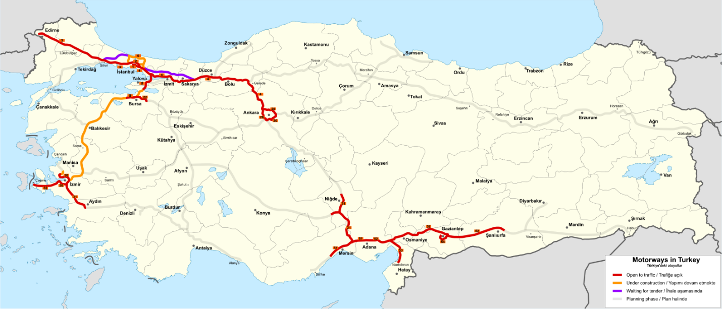

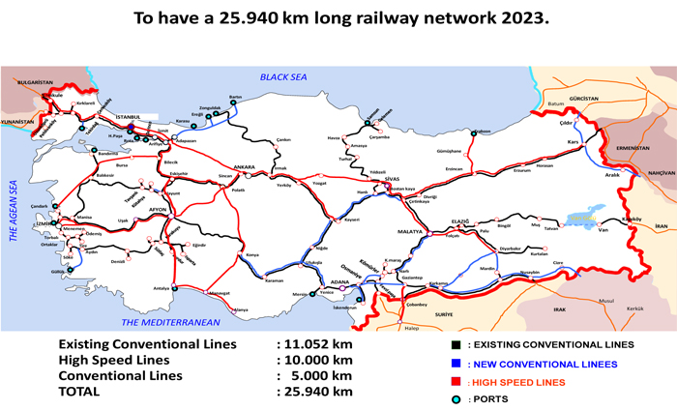

1. Does the network in Turkiye create an advantage or disadvantage in certain areas? Why? (see Figures from Question #3)

Turkiye gives an advantage to the northeast area of the country as it provides it with multiple systems of transportation for citizens to choose from. Whereas they would have to entirely rely on one form of transportation if they were in another part of the country.

1. What other factors might play a role in the structure of this network? (see Figures from Question #3)

Aside from the importance of the strait many factors play a role in the structure of the Turkiye transportation system. The biggest example that comes to mind is that Europe focuses much more on motorways than in comparison to the Middle East. As a result, the motorways of Europe extend into Turkiye. However, due to less focus on motorways in the Middle East those extended Motorways in Turkiye do not go far.

1. What about physical geography? How does this affect connectedness in Turkiye (See map below and Figure 2 from Question #3)

The physical geography directly affects the rail lines of Turkiye and thus the connectedness in Turkiye. Given rail lines are difficult to construct on mountainous terrain the rail lines are more prevalent to the western side of the country to avoid the Taurus Mountains and Armenian Highlands. Making those regions much less connected than the rest of the country.

